Student Name: Rudrashis Chowdhury
AF Code: AF05248027
Project Title: Electricity Bill & Energy Consumption Analysis
Project Duration: 3 Days
Trainer Name: Sayan Sau
Submission Date: 10/07/2026
GitHub Username: Ishan2025-new
GitHub Repository Link: https://github.com/Ishan2025-new/Electricity-Bill-and-Energy-Consumption-Analysis
Project Objective
The objective of this project is to analyze household electricity consumption data using Microsoft Excel and transform raw data into meaningful business insights. The project focuses on cleaning and organizing data, calculating energy usage, identifying consumption trends, and building an interactive dashboard for effective decision-making. The analysis helps users monitor electricity usage patterns, compare consumption across different cities and appliances, and support energy-saving initiatives.
Tools & Technologies Used
- Microsoft Excel
- Pivot Tables
- Pivot Charts
- Slicers
- Excel Tables
- IF Functions, Upper Case Functions
- Find and Replace Values
- Dashboard Design
- Data Cleaning Techniques
Dataset Description
The dataset contains electricity consumption records collected from multiple cities. It includes monthly electricity usage, appliance-wise energy consumption, refrigerator rates, fan usage, monthly operating hours, and other related information. The dataset was cleaned and transformed before performing analysis to ensure accuracy and consistency.

Key Features
- Data Cleaning and Transformation
- Interactive Dashboard with Slicers
- City-wise Electricity Consumption Analysis
- Monthly Energy Consumption Report
- Fan Usage Analysis by City
- Refrigerator Rate Comparison
- Monthly Operating Hours Analysis
- Pivot Tables and Pivot Charts
- KPI-Based Dashboard
- Dynamic Reporting for Better Decision Making
Screenshots
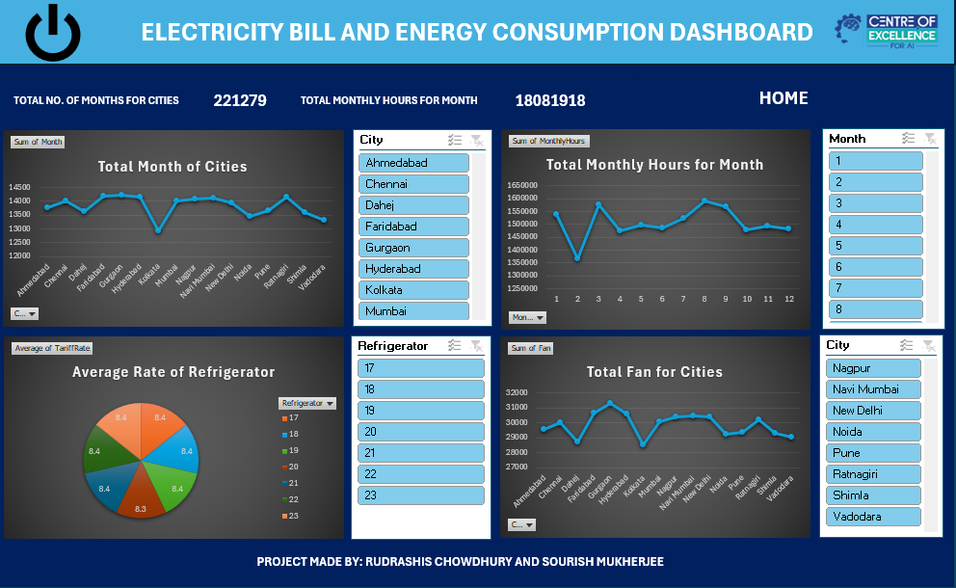

Learning Outcome
During this project, I enhanced my practical knowledge of Advanced Microsoft Excel by working with real-world datasets. I learned how to clean and organize large datasets, create Pivot Tables and Pivot Charts, apply advanced formulas and functions, build interactive dashboards using slicers, and present data visually through charts. This project also improved my analytical thinking, reporting skills, and ability to convert raw data into actionable insights for business decision-making.
Conclusion
The Electricity Bill & Energy Consumption Analysis project successfully demonstrates how Advanced Excel can be used for data analysis and business reporting. The dashboard provides a clear visualization of electricity consumption patterns across different cities and appliances, enabling users to identify trends and make informed decisions. The project highlights the importance of data cleaning, automation, visualization, and reporting in solving real-world analytical problems.
GitHub Repository Submission
GitHub Repository Link: https://github.com/Ishan2025-new/Electricity-Bill-and-Energy-Consumption-Analysis
GitHub Username: Ishan2025-new
Repository Name: Electricity-Bill-Energy-Consumption-Analysis

